**ALL Tanner Tools Projects**

**INVERTER**

**S-EDIT**

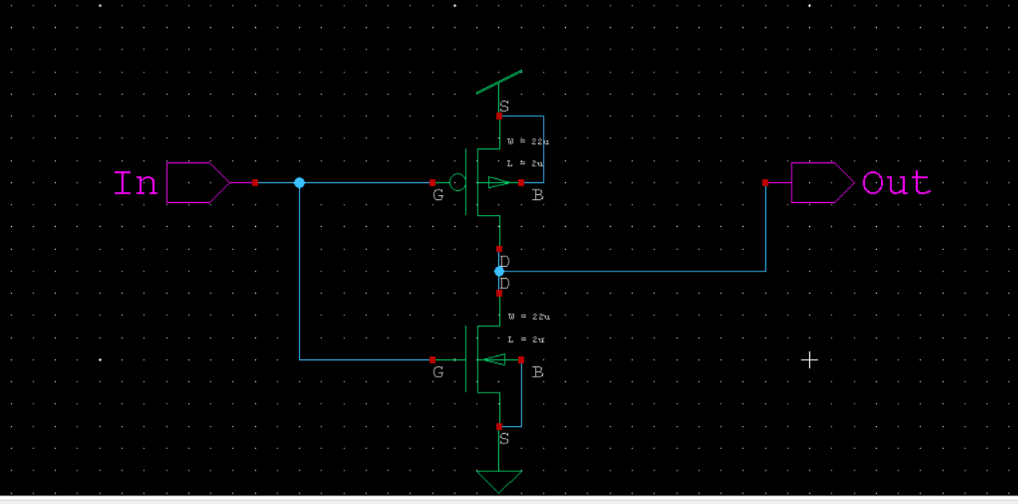

**T – SPICE**

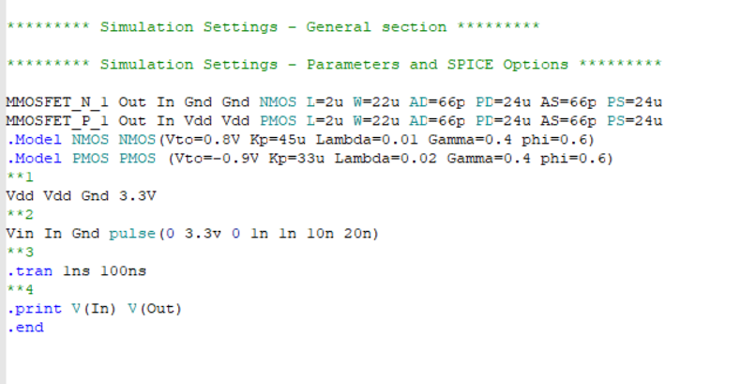

**W-EDIT WAVEFORM**

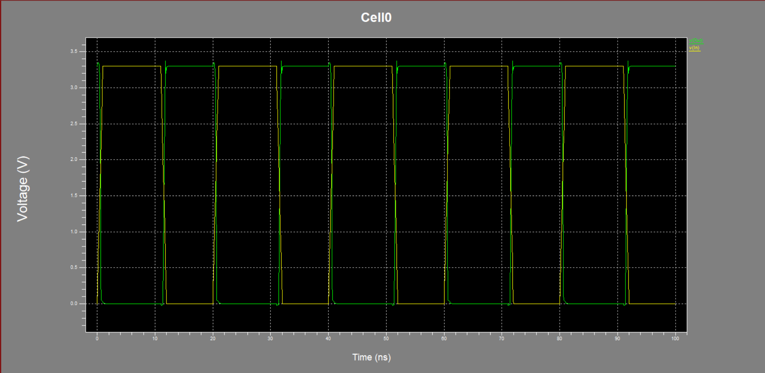

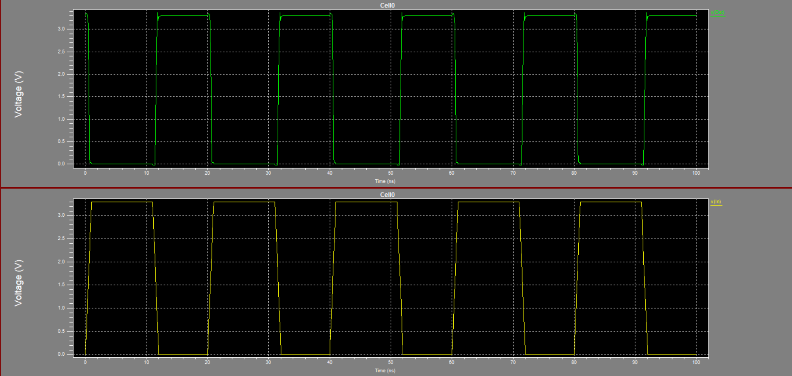

**NAND GATE**

**S-EDIT**

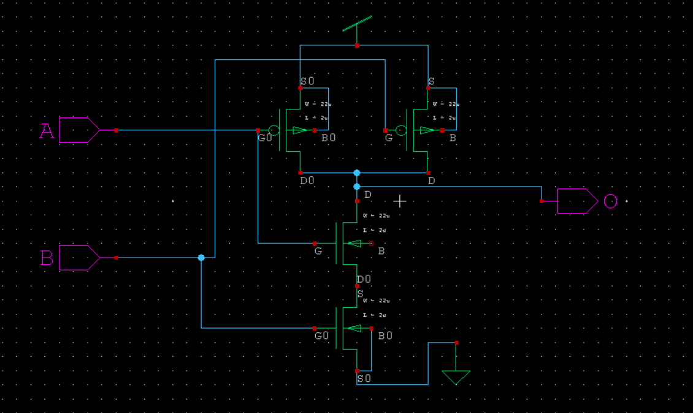

**T-SPICE**

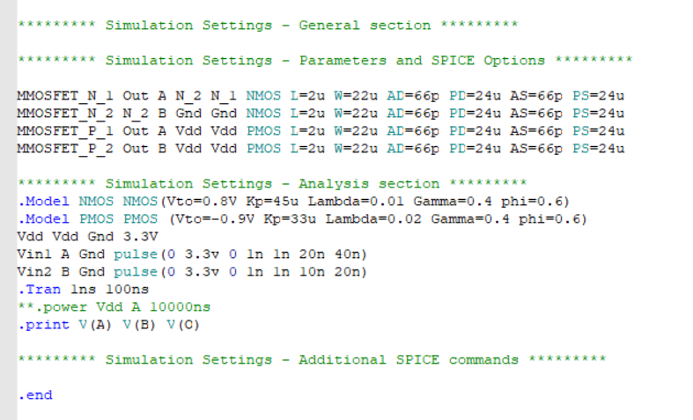

**W-EDIT WAVEFORM**

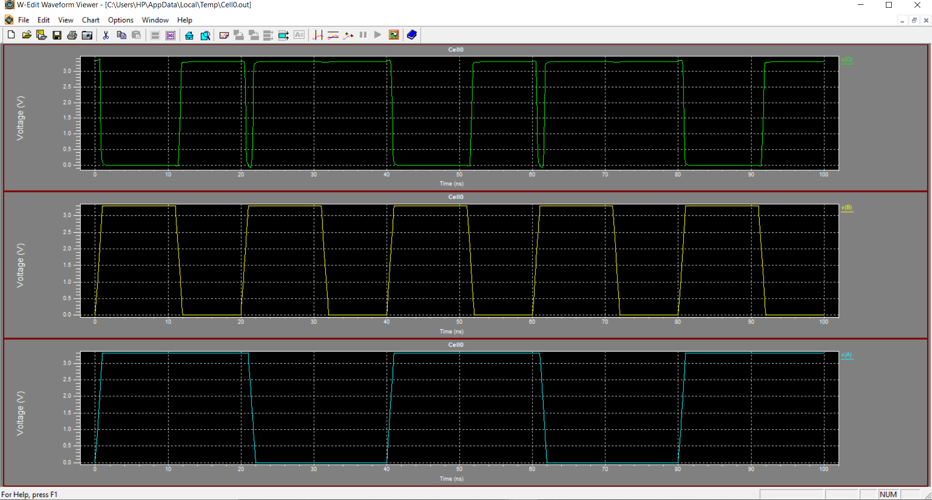

**NOR GATE**

**S-EDIT**

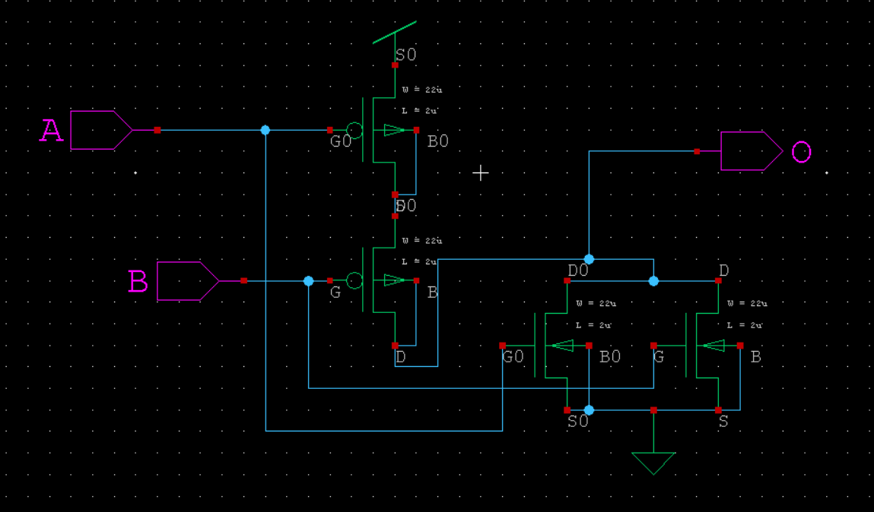

**T-SPICE**

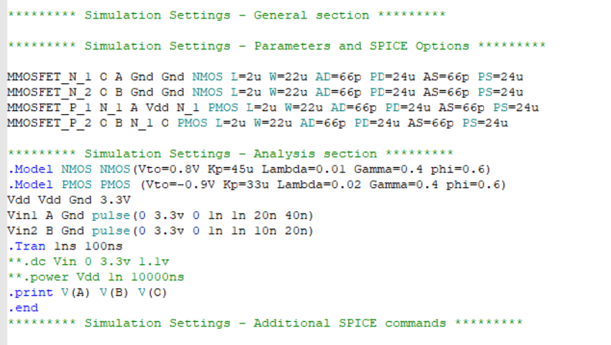

**W-EDIT WAVEFORM**

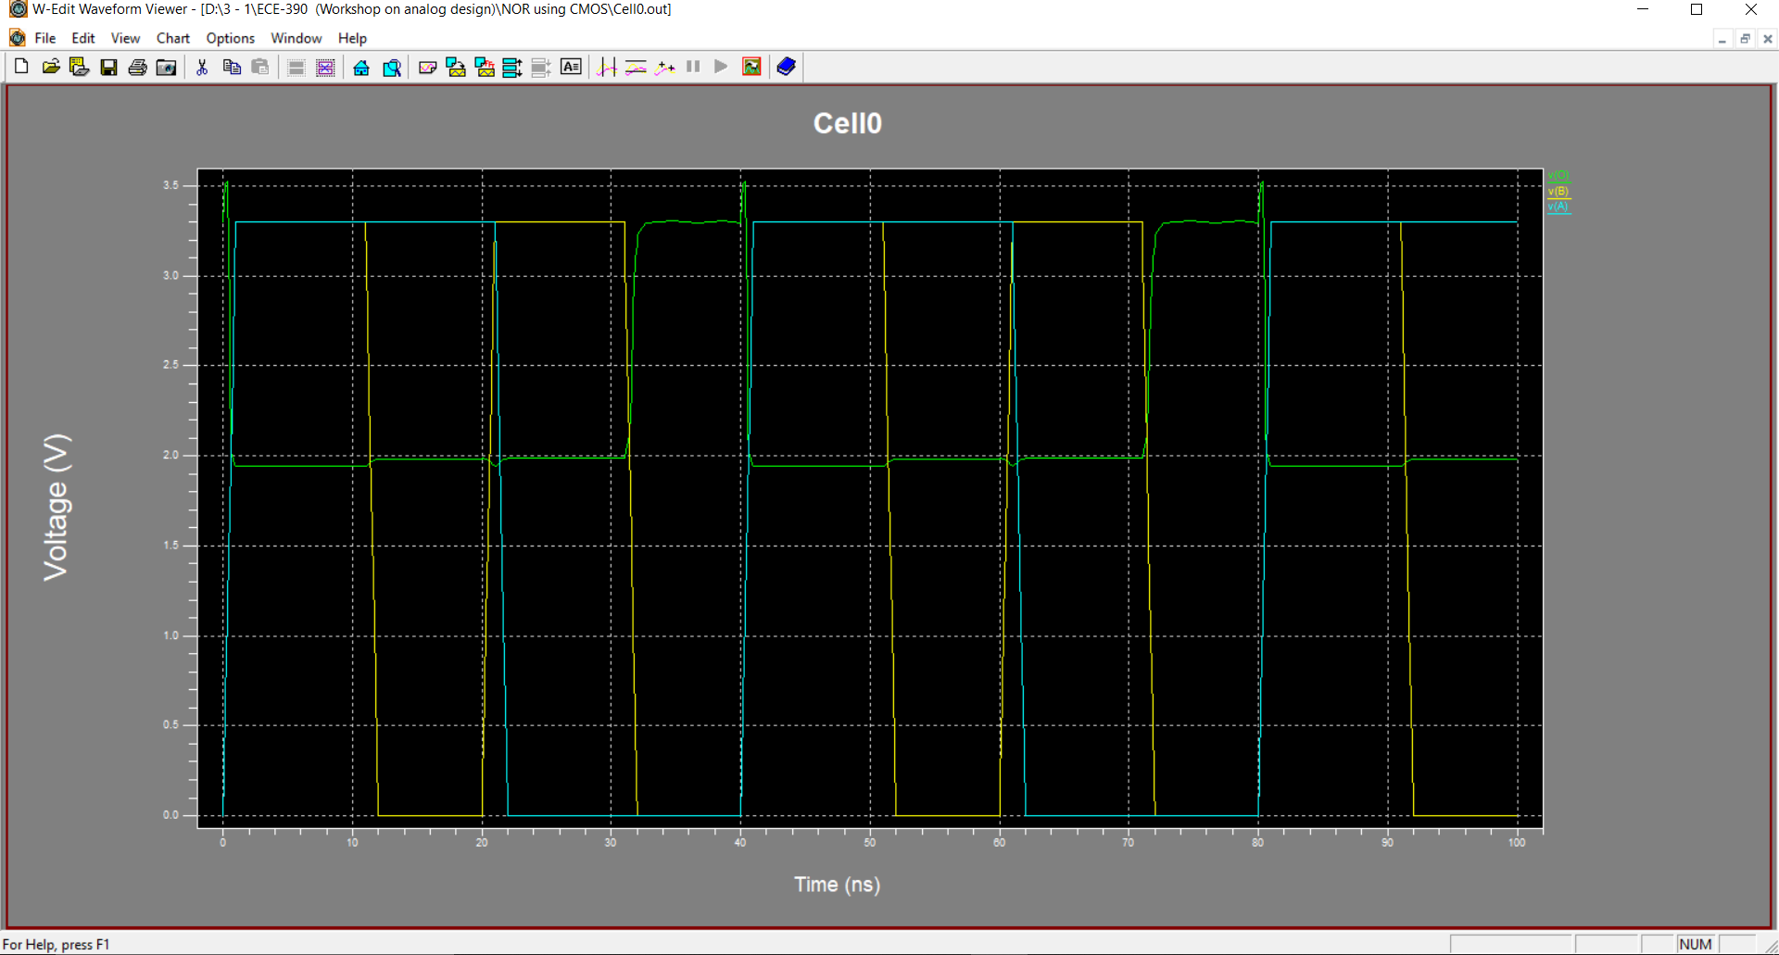

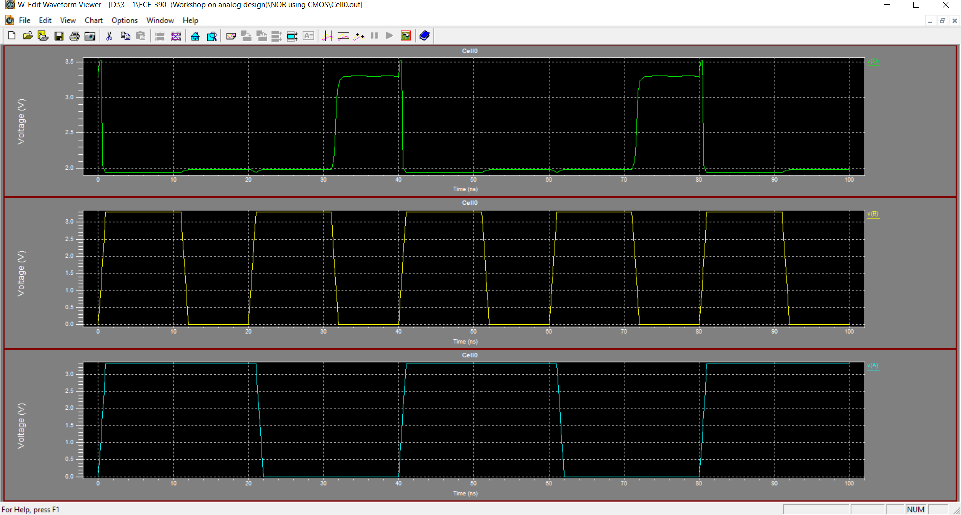

**HALF ADDER**

**S-EDIT**

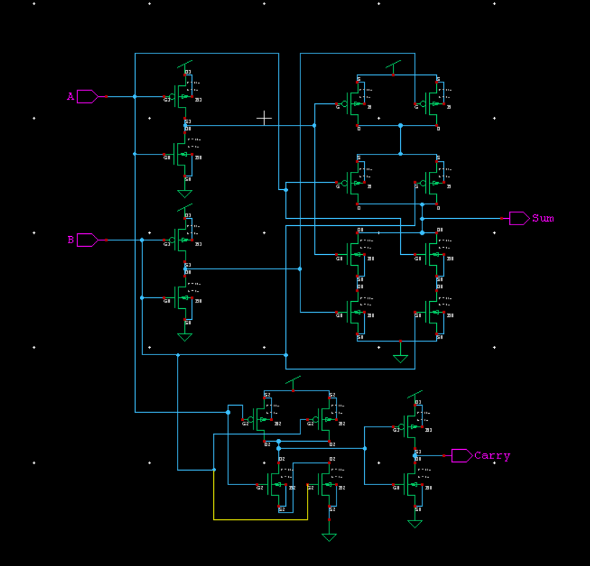

**T-SPICE**

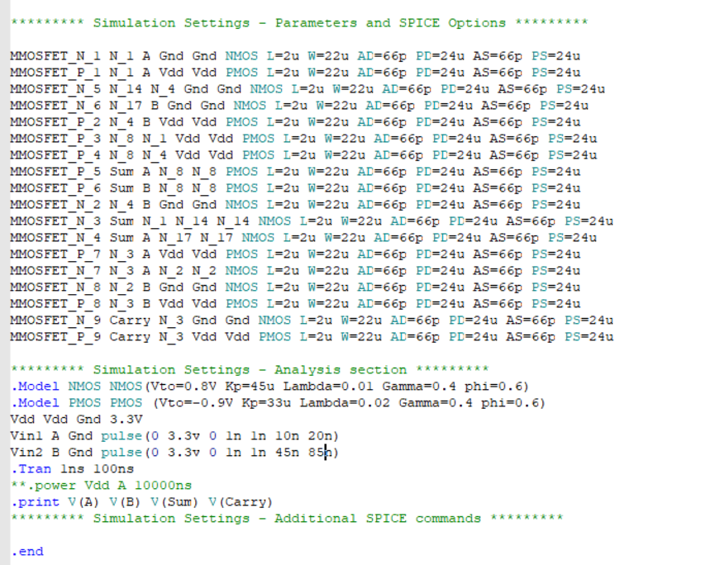

**W-EDIT WAVEFORM**

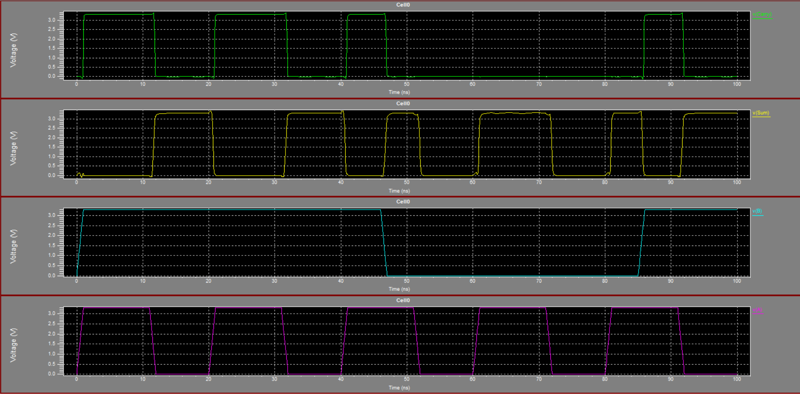

**FULL ADDER**

**S-EDIT**

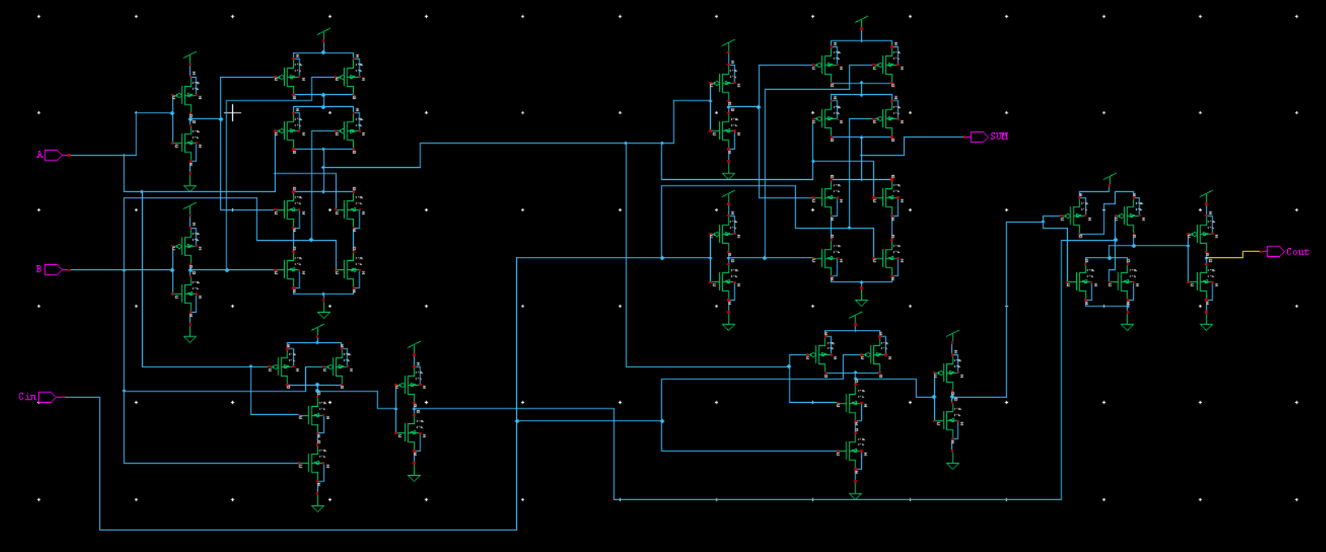

**T-SPICE**

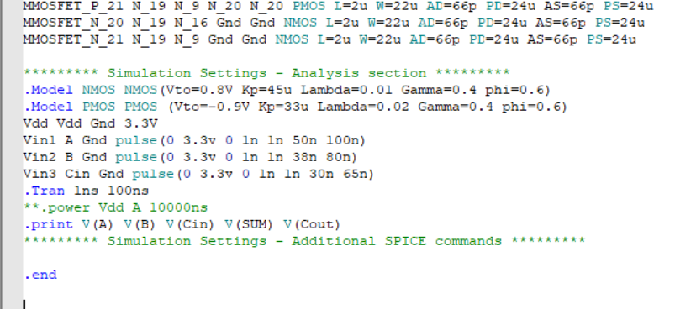

**W-EDIT WAVEFORM**

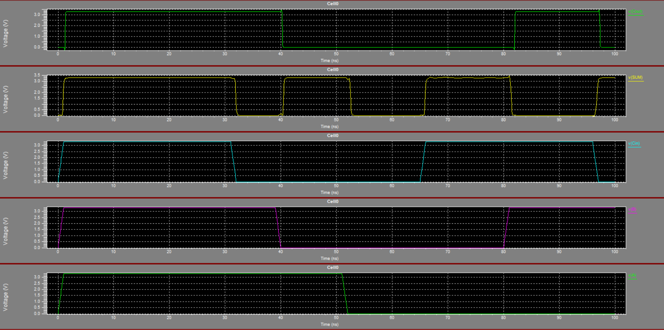

**INPUT WAVEFORM**

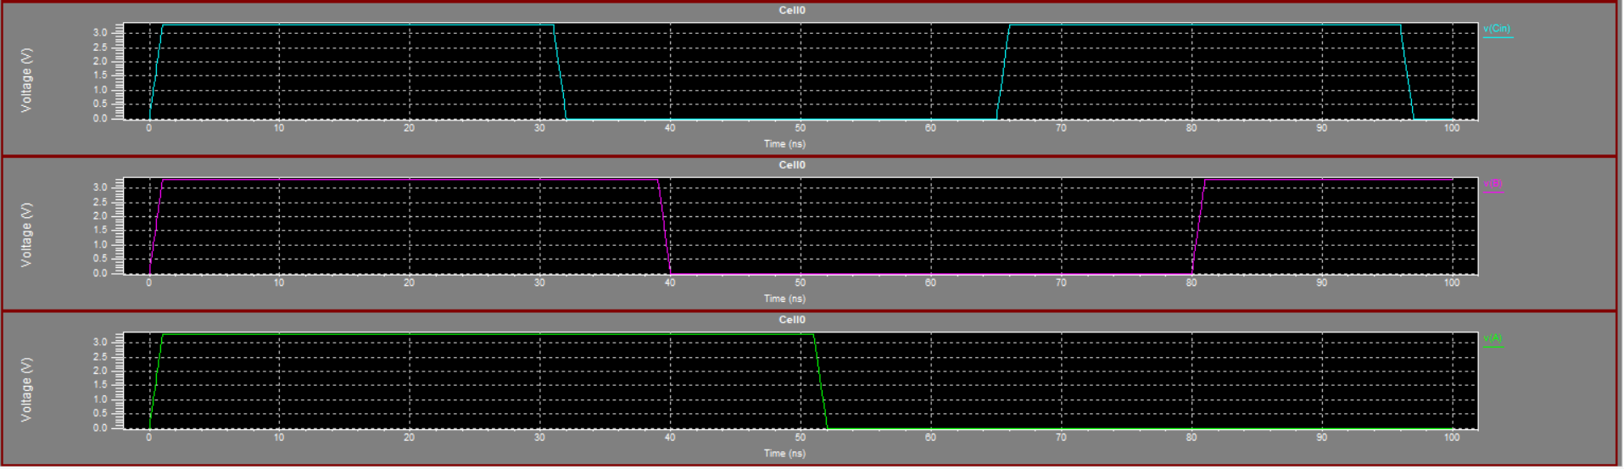

**OUTPUT WAVEFORM**

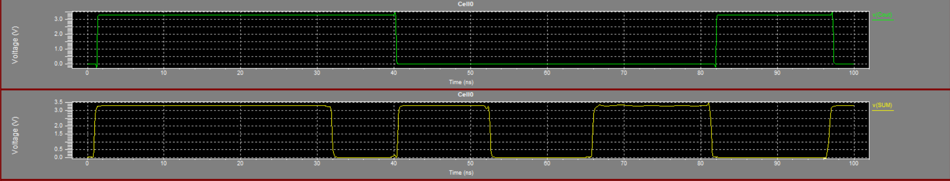

**EDGE TRIGGERED D FLIP FLOP**

**S-EDIT**

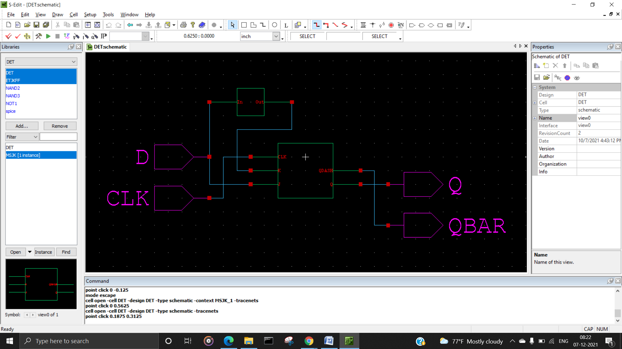

**INTERNAL MASTER SLAVE jk flipflop**

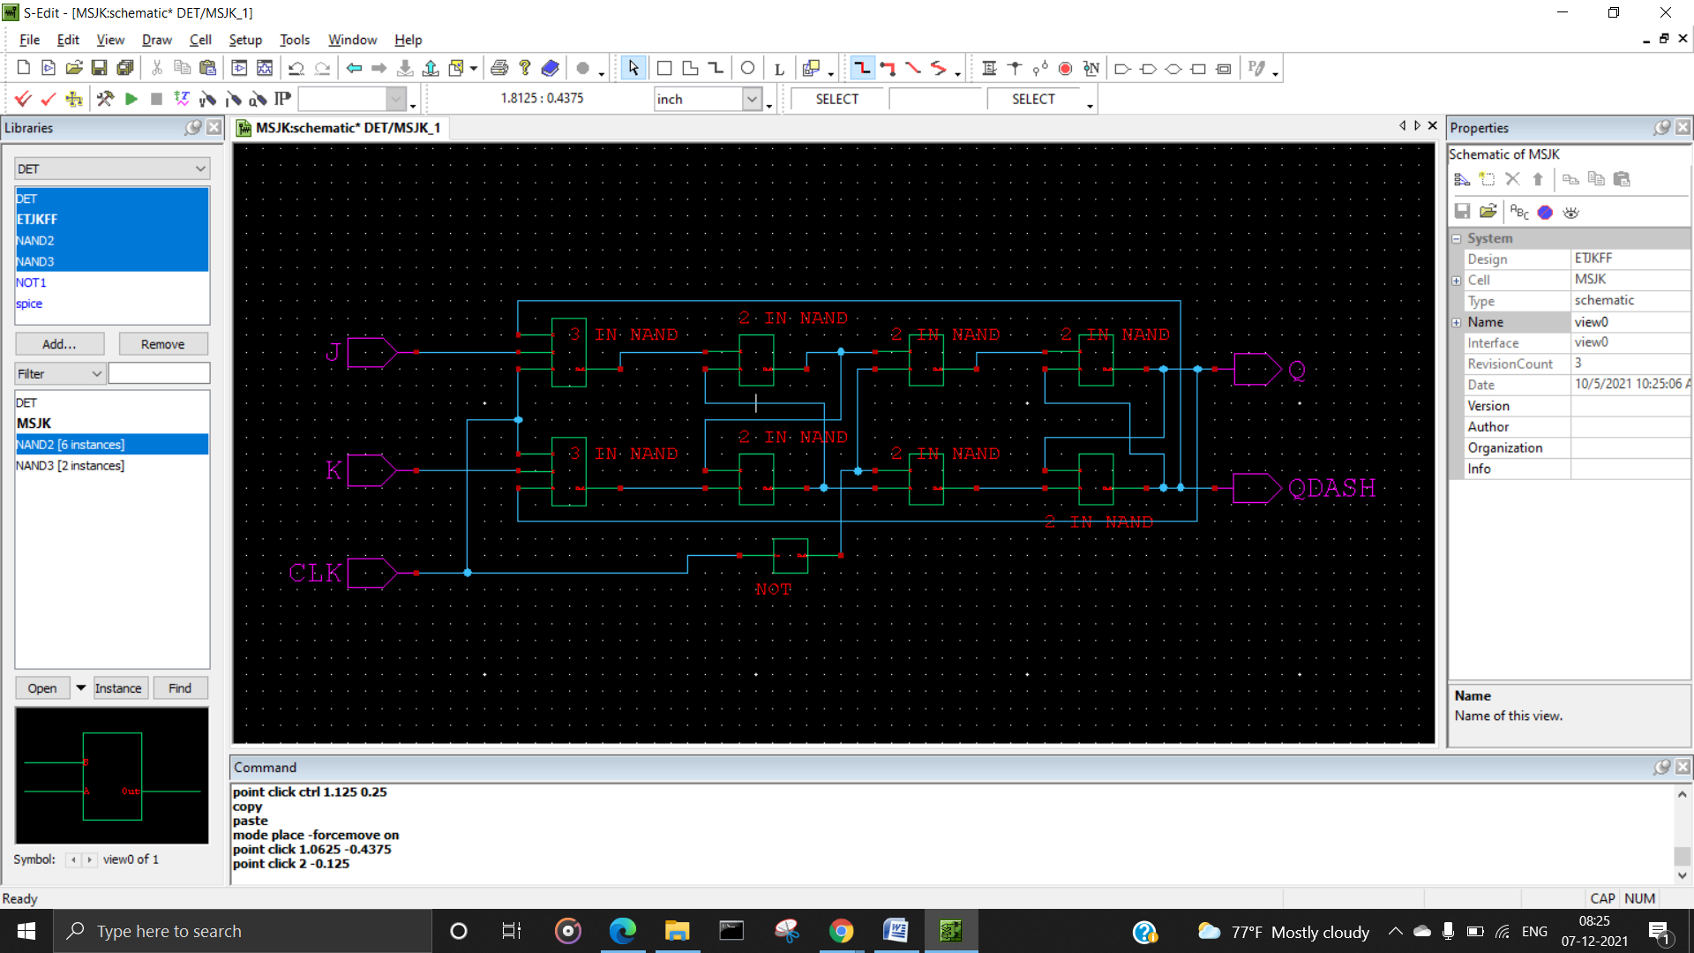

**T-SPICE**

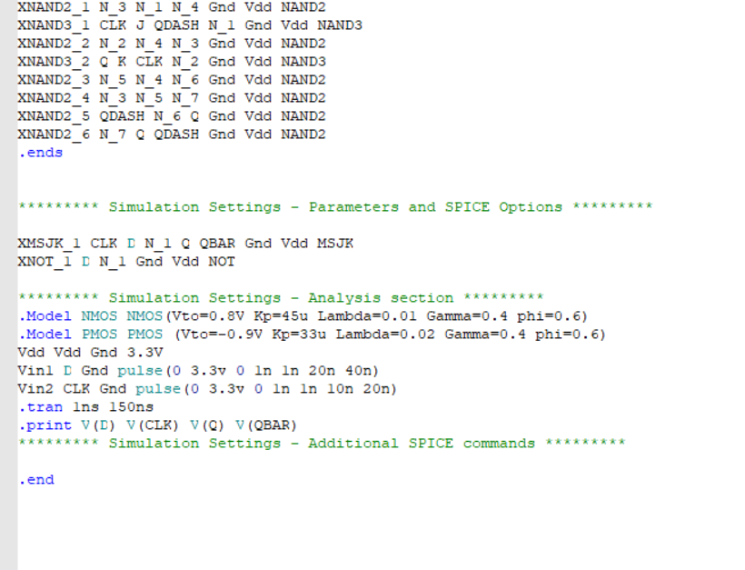

**W-EDIT WAVEFORM**

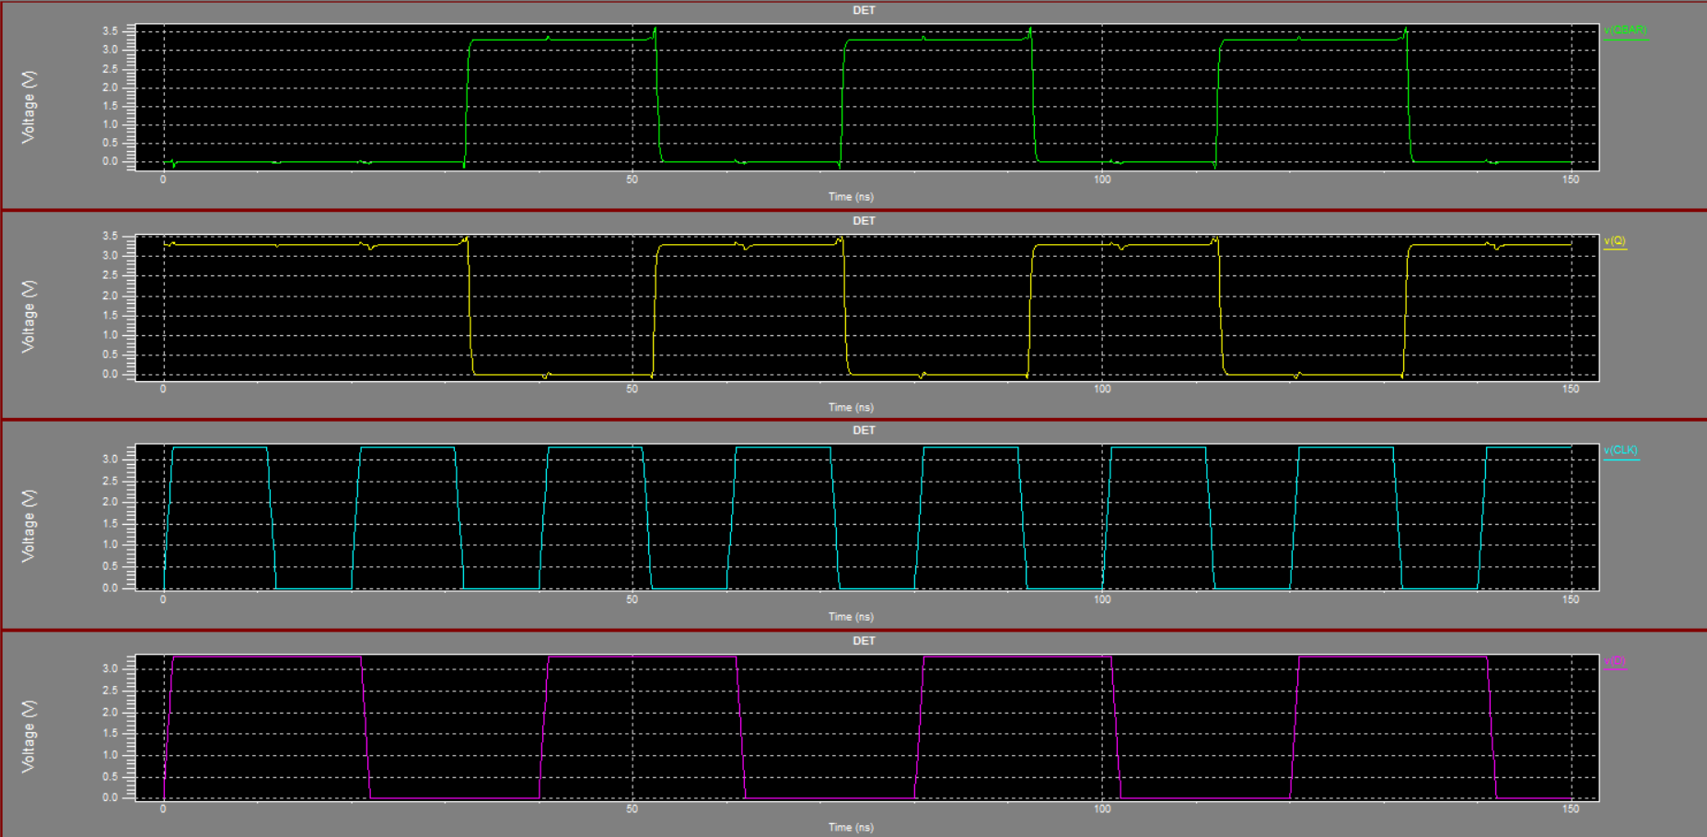

**STANDARD LFSR**

**S-EDIT**

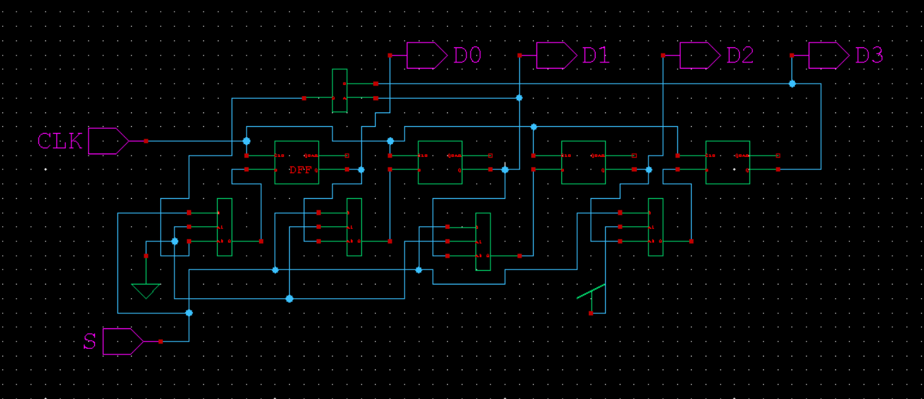

**T-SPICE**

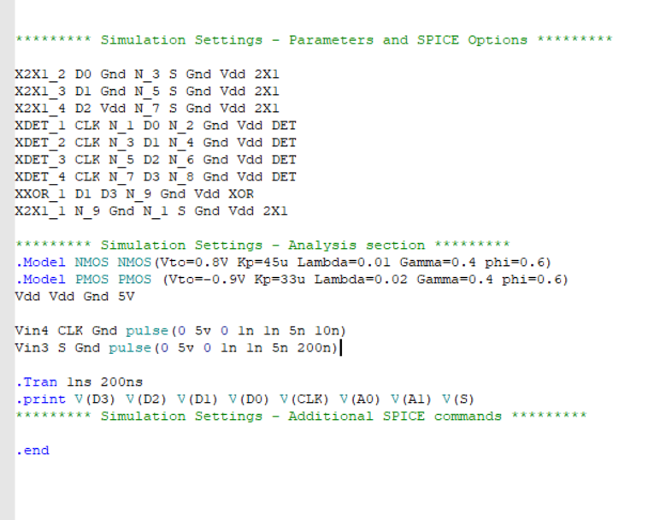

**W-EDIT WAVEFORM**

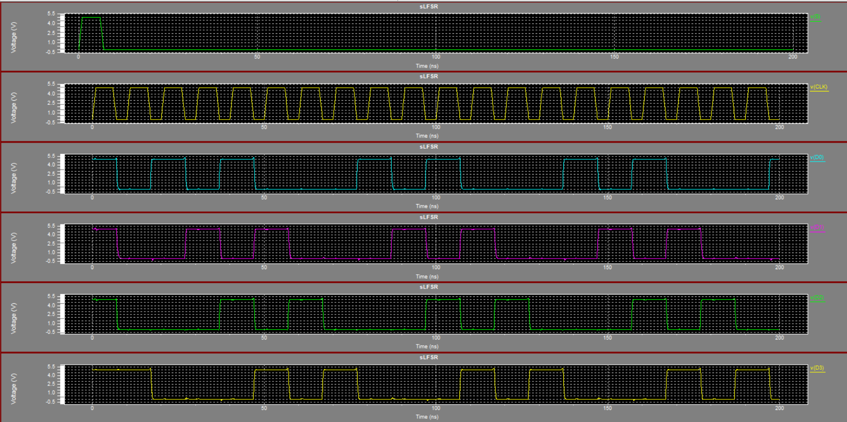

**MODULAR LFSR**

**S-EDIT**

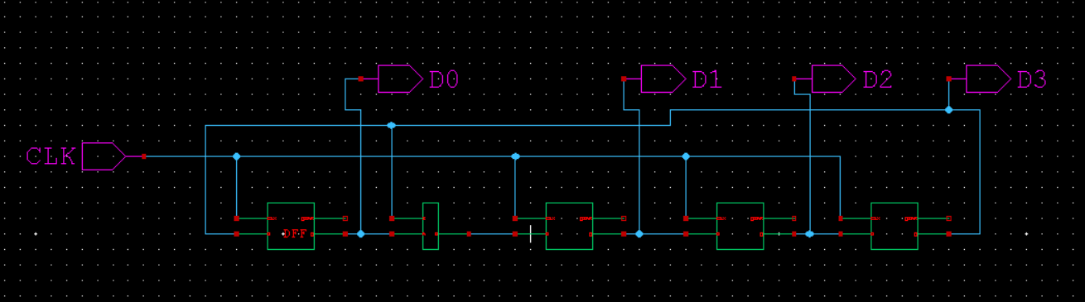

**T-SPICE**

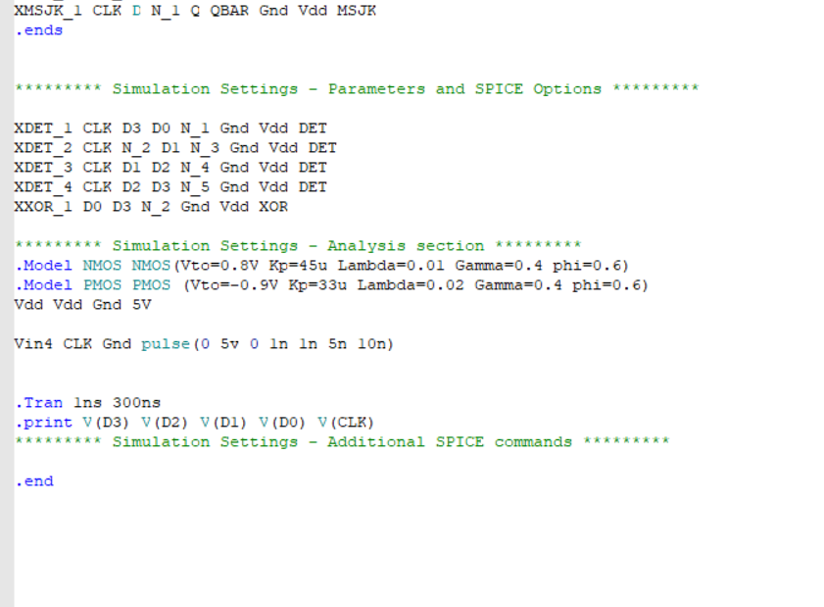

**W-EDIT WAVEFORM**

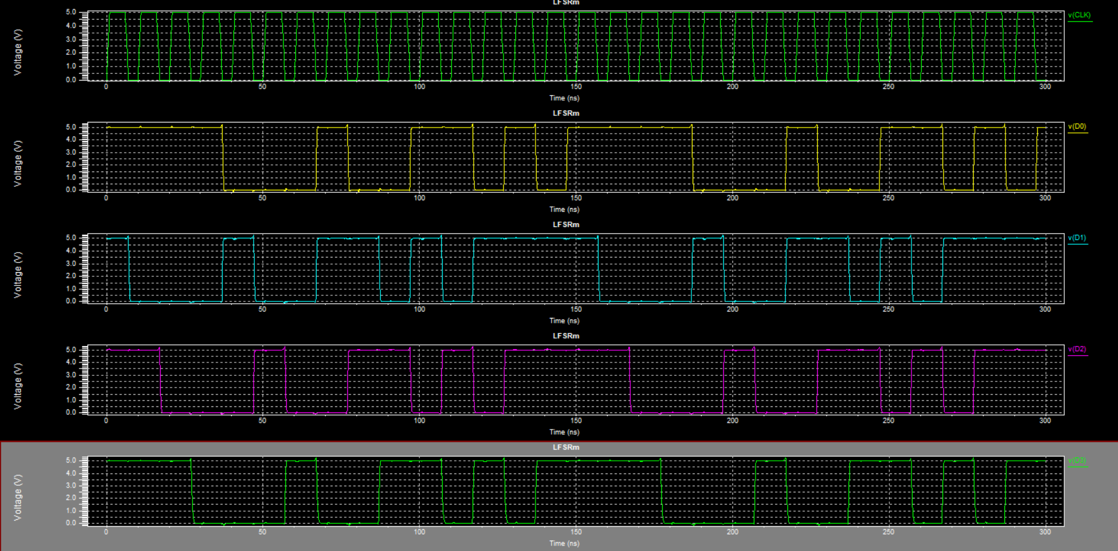

**SRAM CELL**

**S-EDIT**

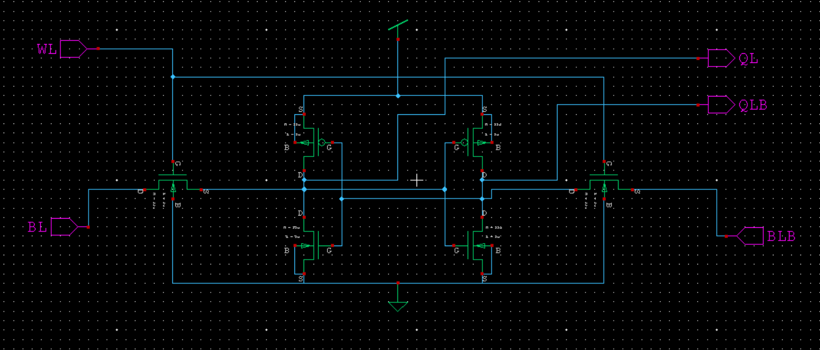

**T-SPICE**

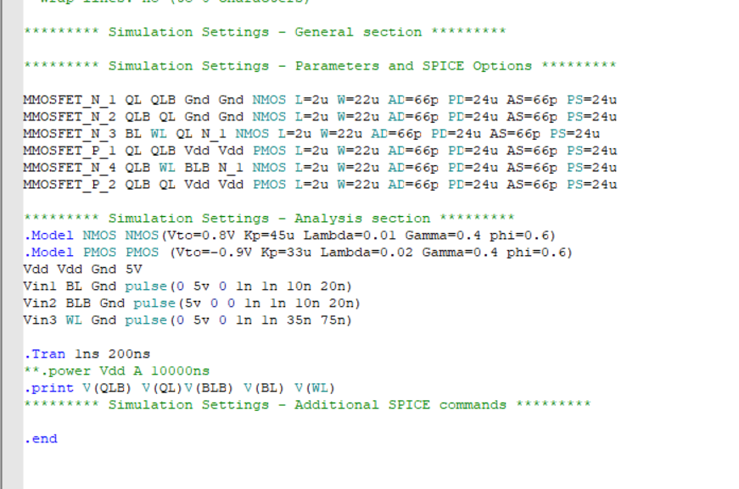

**W-EDIT WAVEFORM**

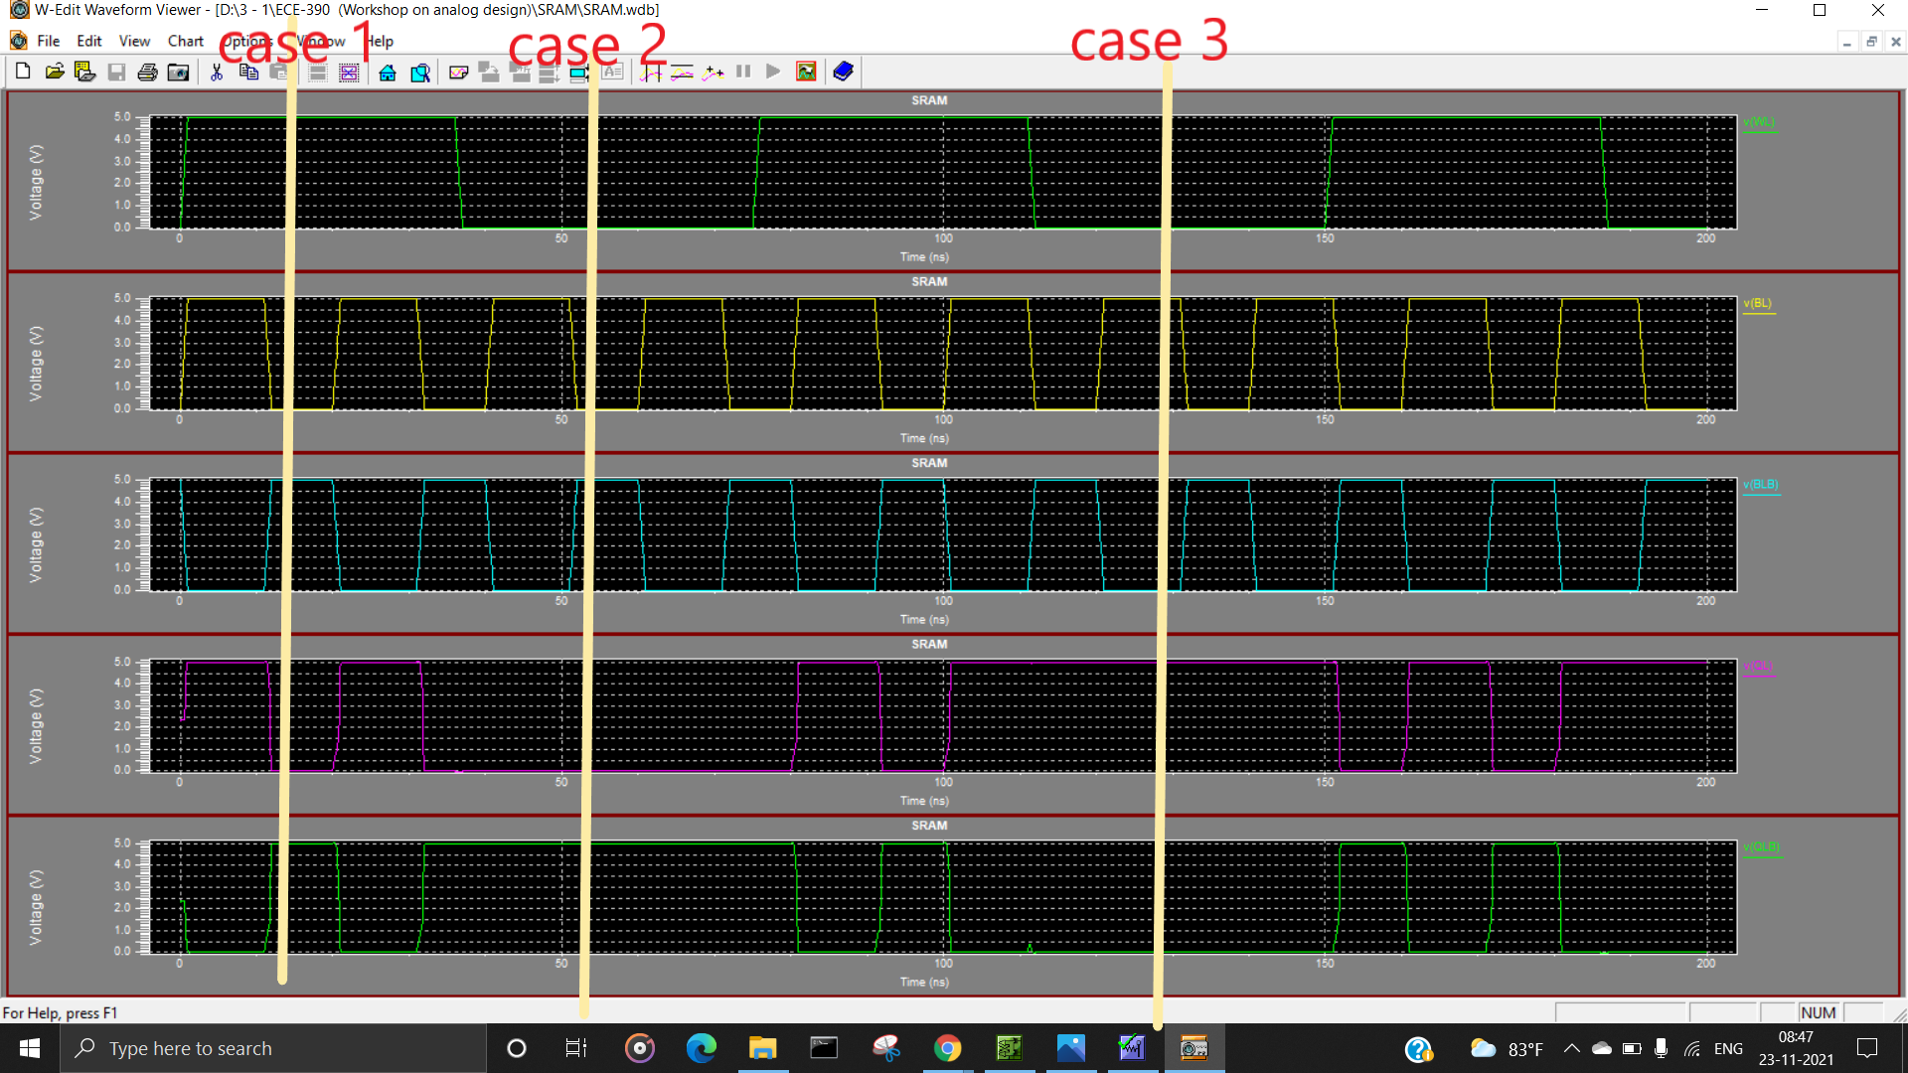

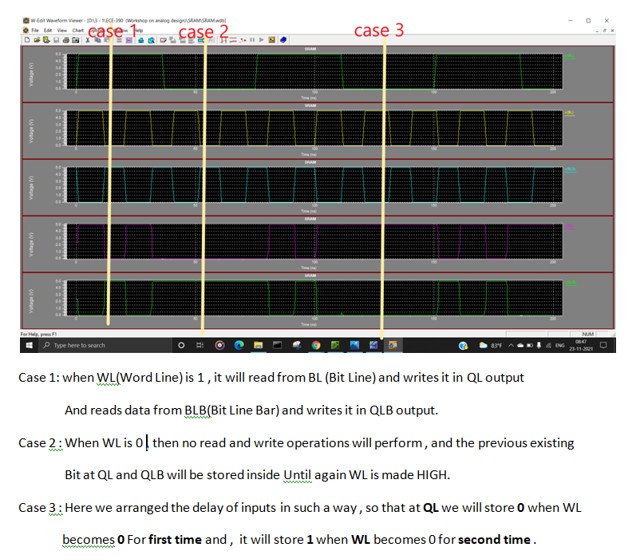

**2 BIT ALU**

**S-EDIT**

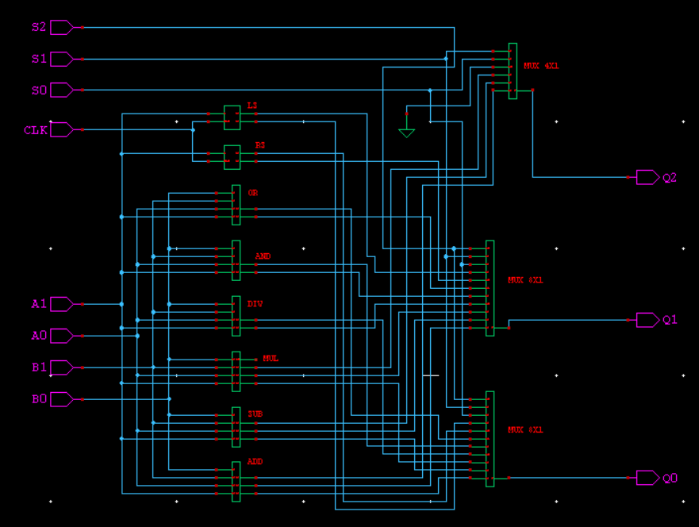

**INTERNAL CIRCUITS**

**ADDER**

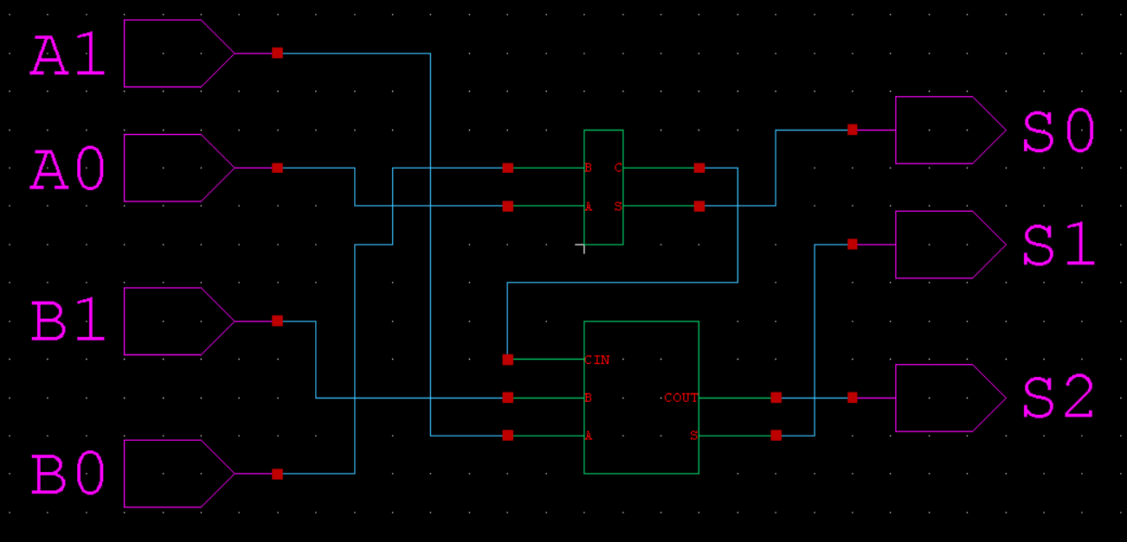

**SUBTRACTOR**

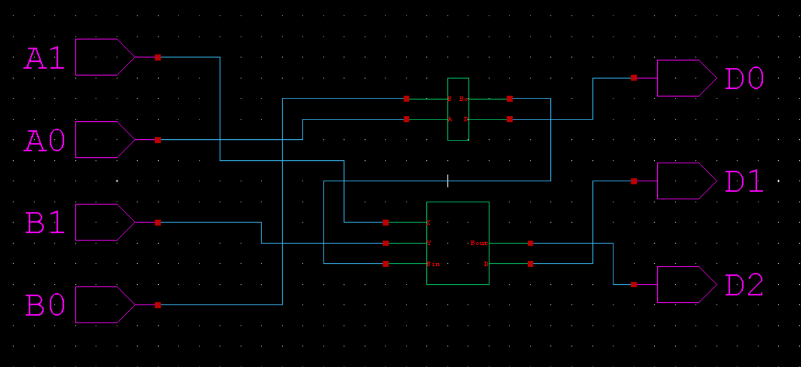

**MULTIPLIER**

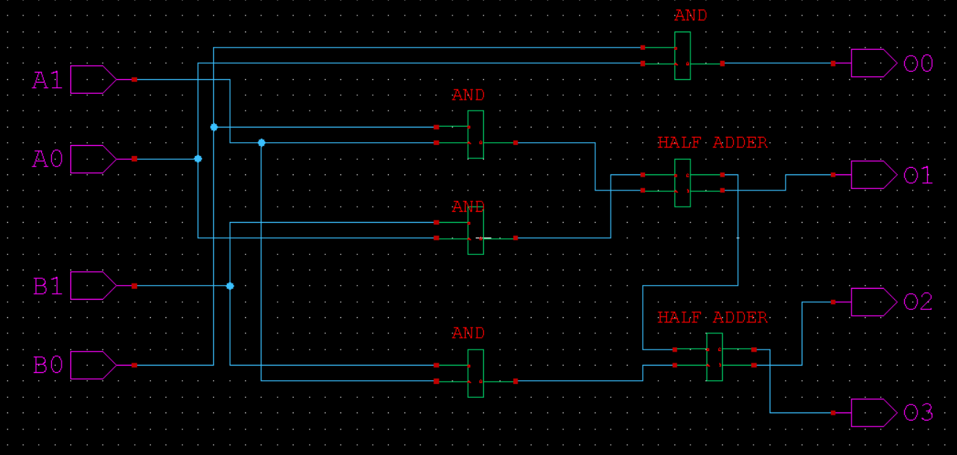

**DIVIDER**

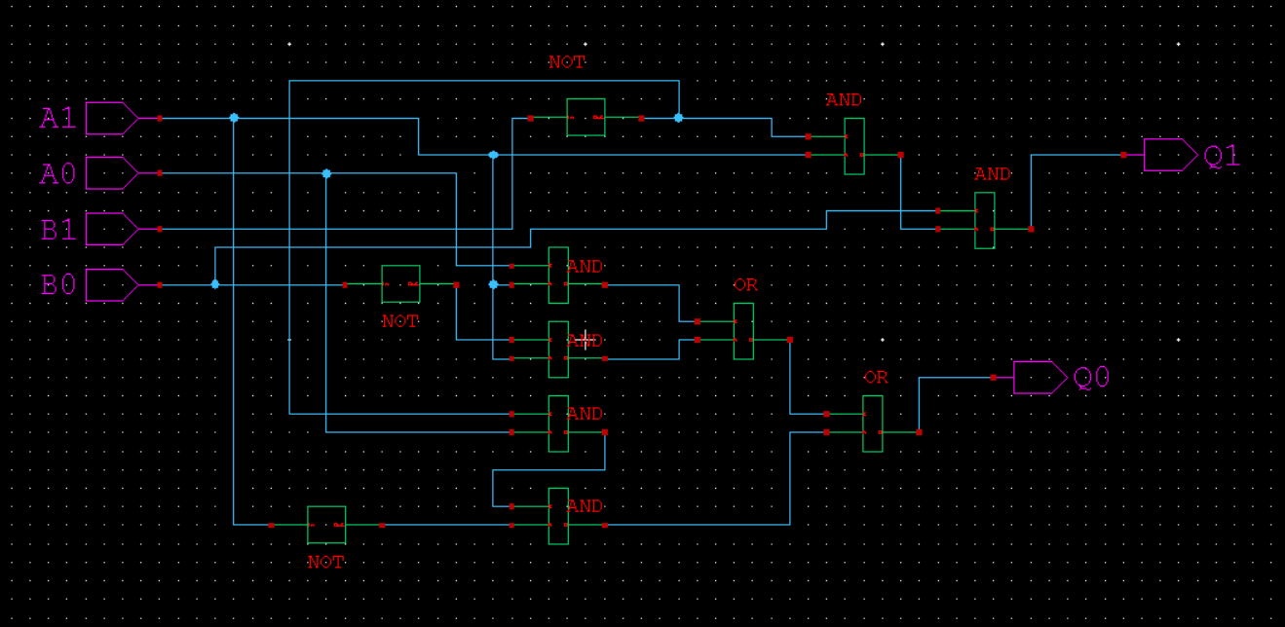

**2 BIT LOGICAL AND**

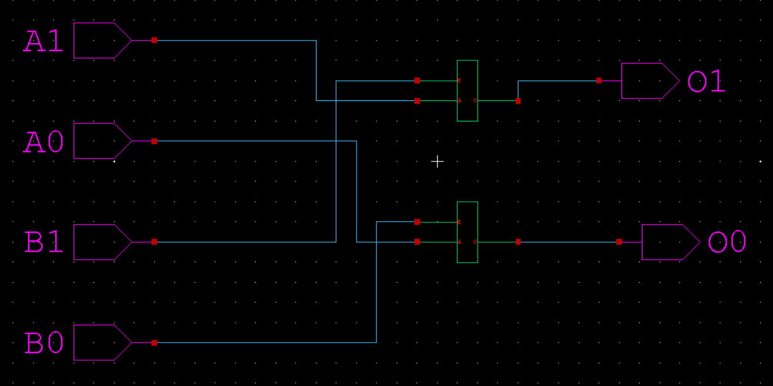

**2 BIT LOGICAL OR**

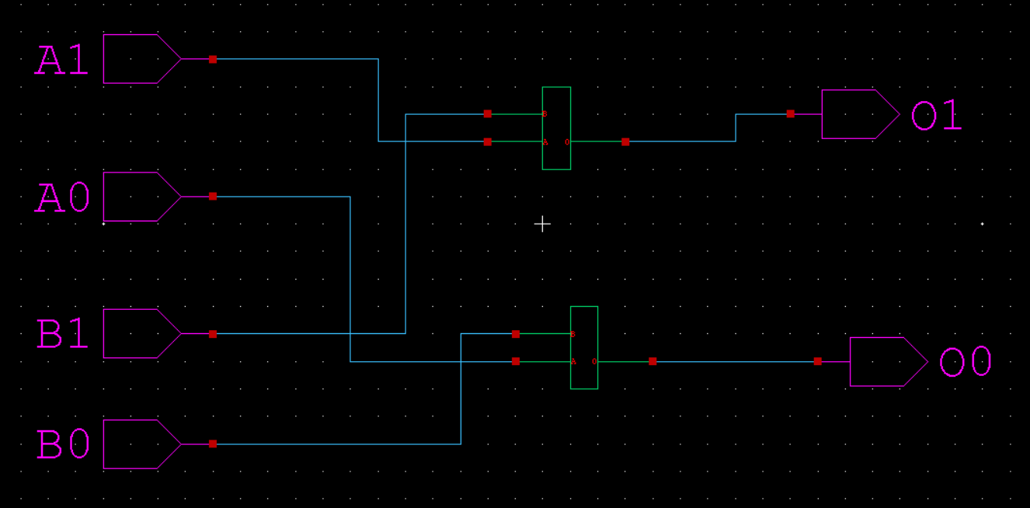

**RIGHT SHIFT**

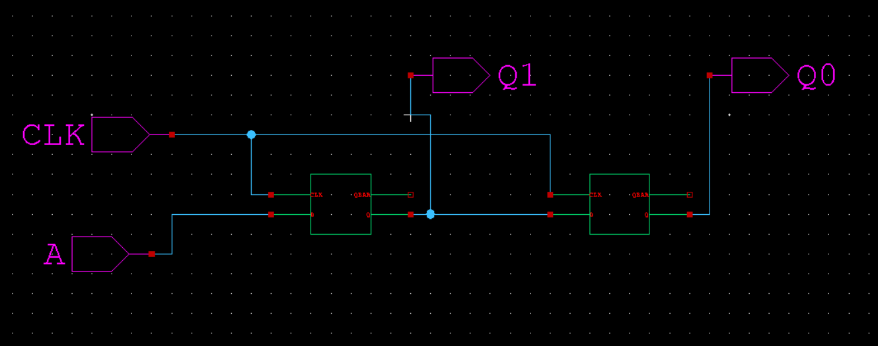

**LEFT SHIFT**

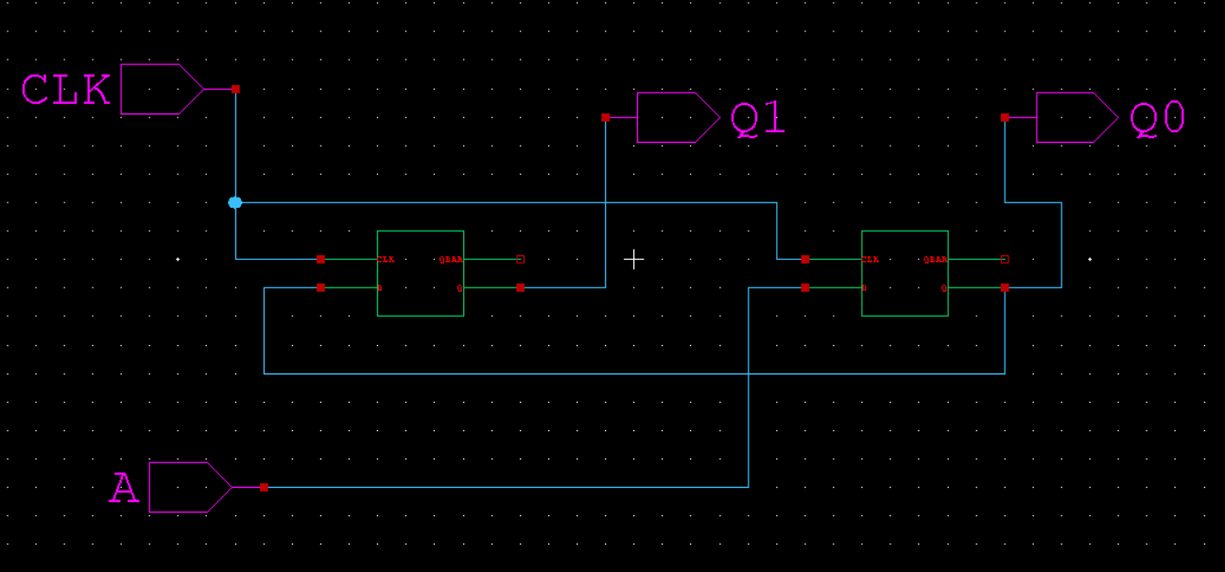

**8X1 MUX**

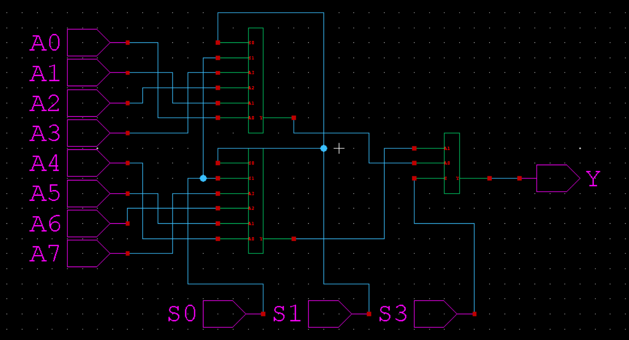

**4X1 MUX**

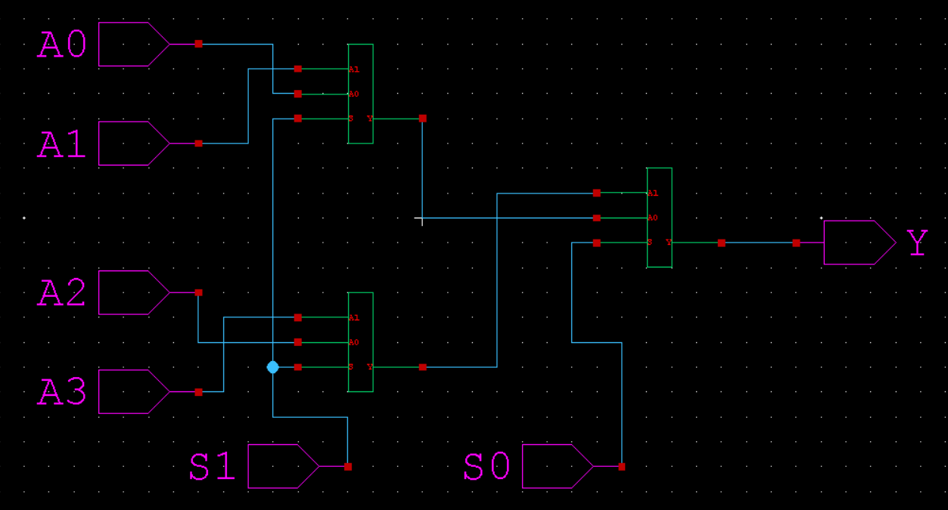

**2X1 MUX (TRANSITION MODEL)**

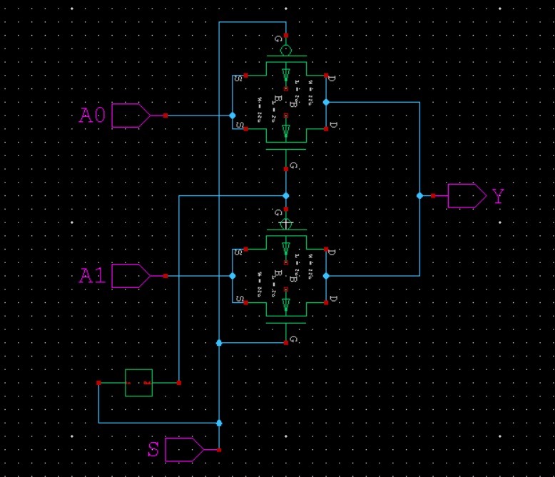

**T-SPICE**

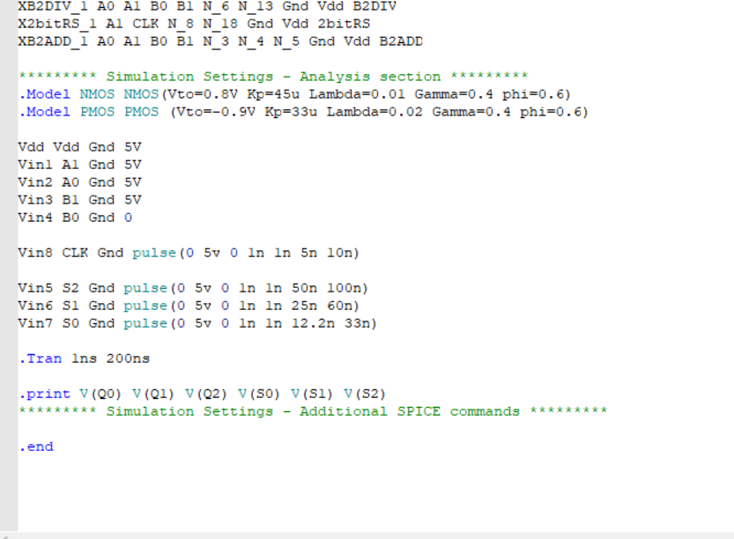

**W-EDIT WAVEFORM**

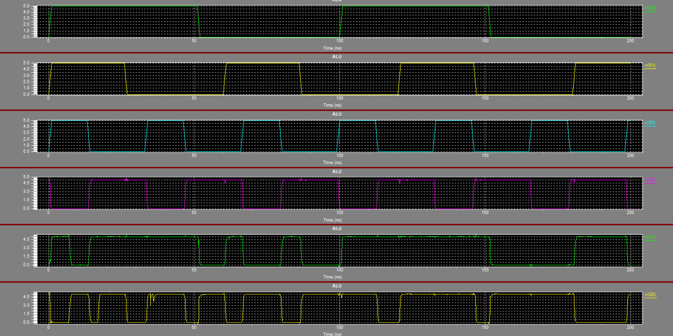

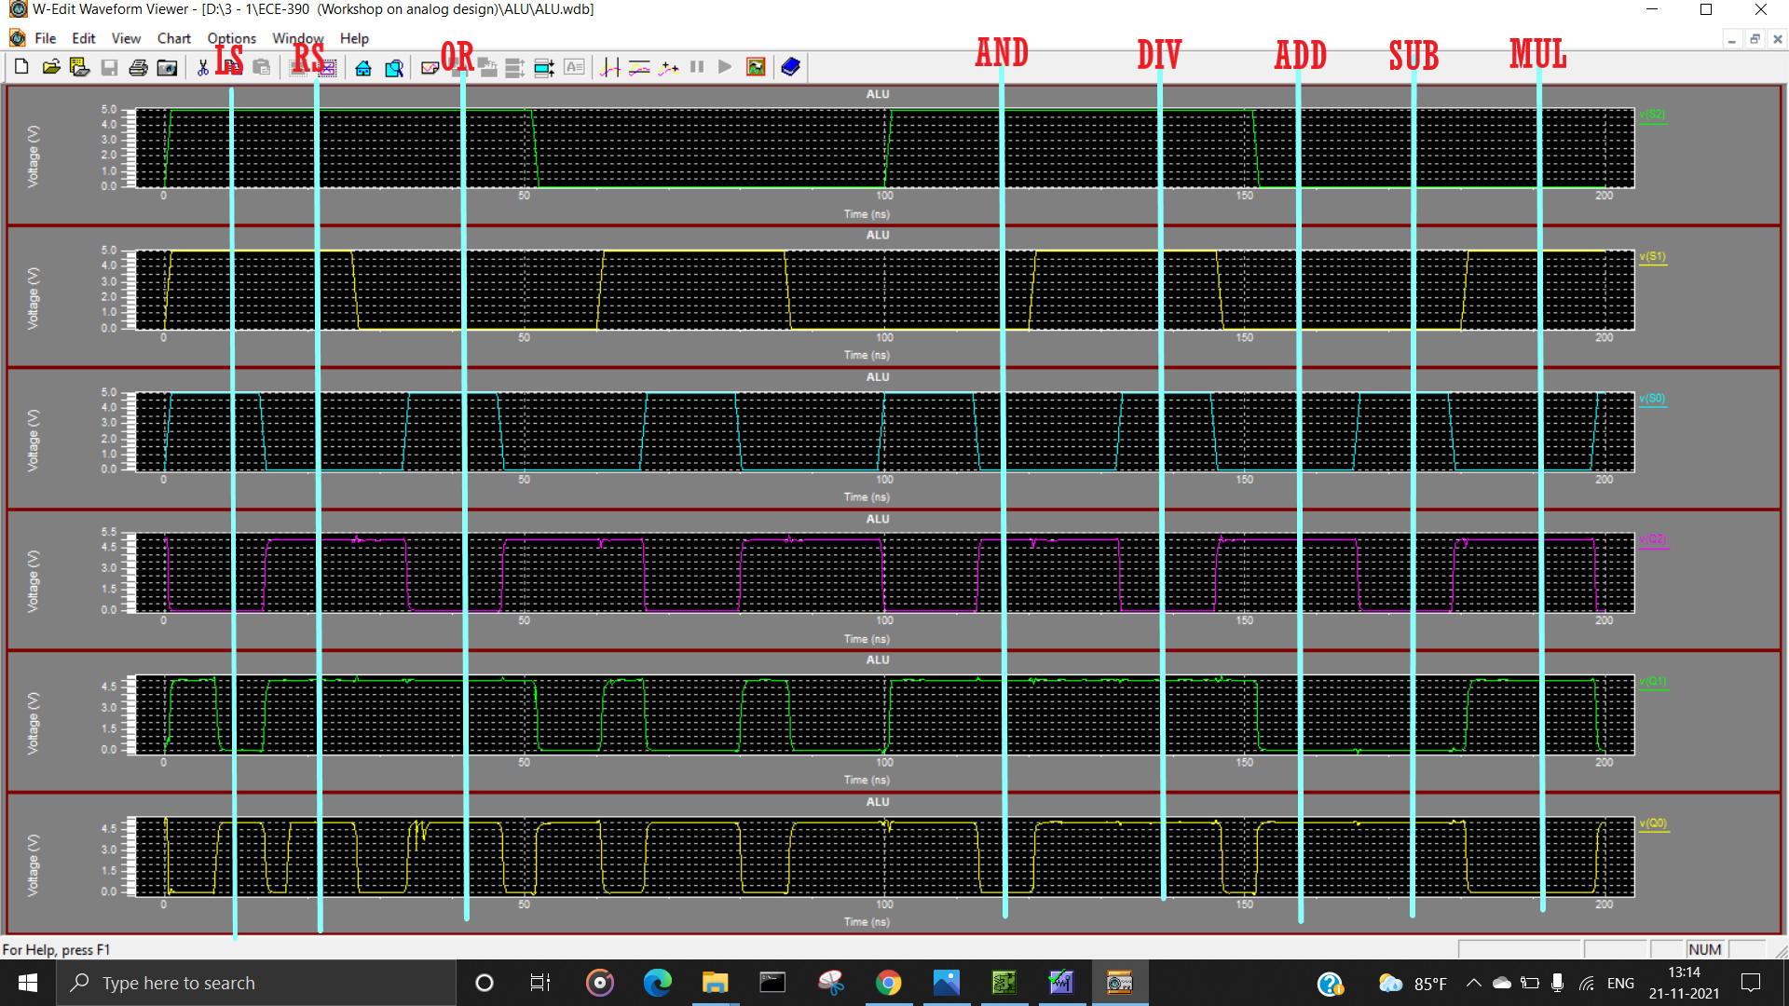

**8 BIT MULTIPLEXER**

**S-EDIT**



**T-SPICE**

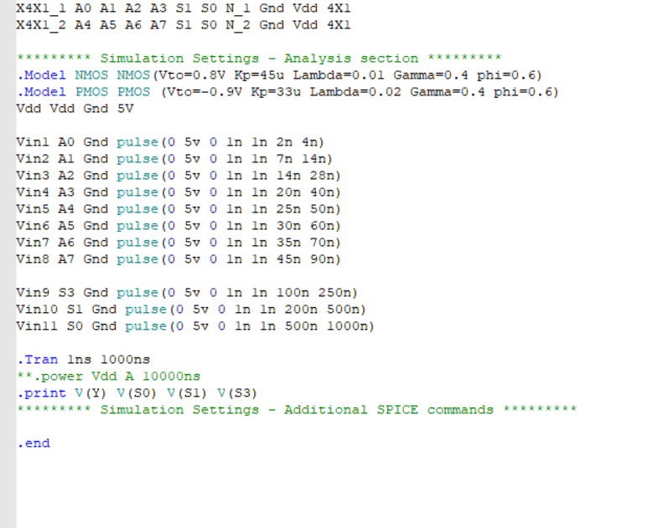

**W-EDIT WAVEFORM**

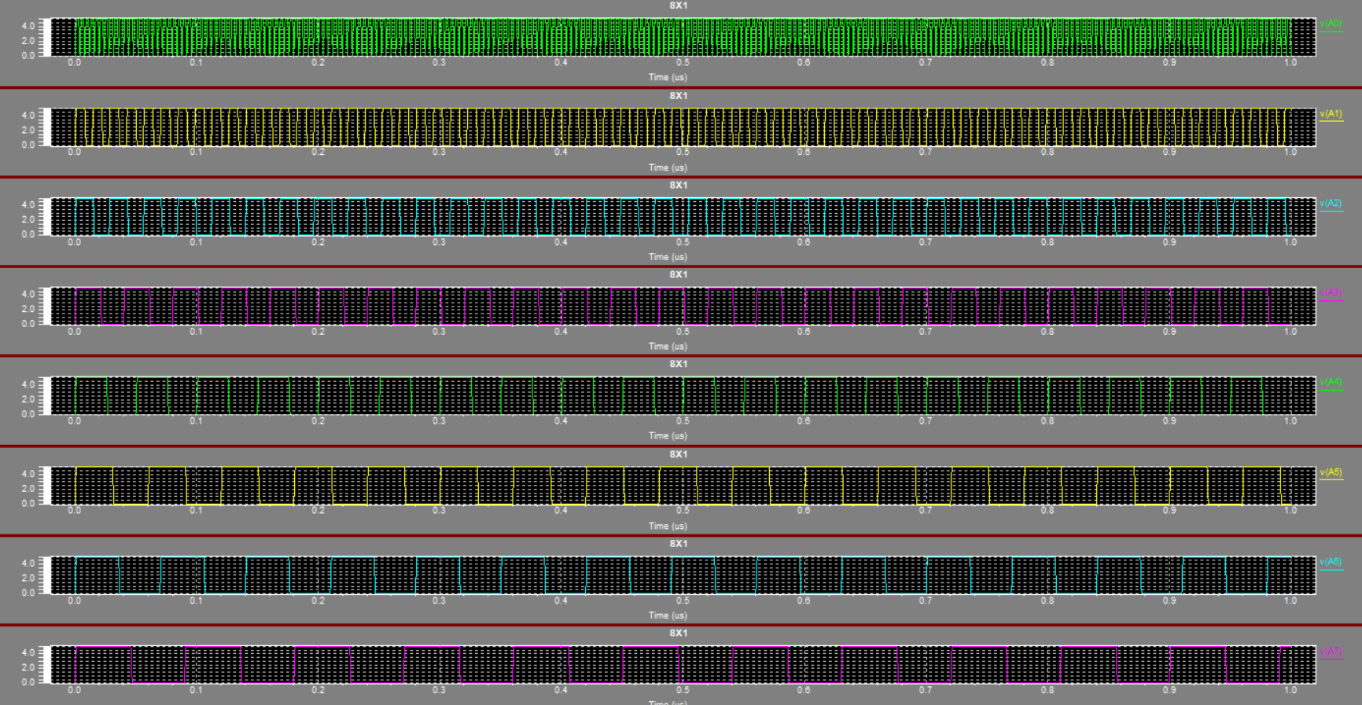

**ROM**

**S-EDIT**

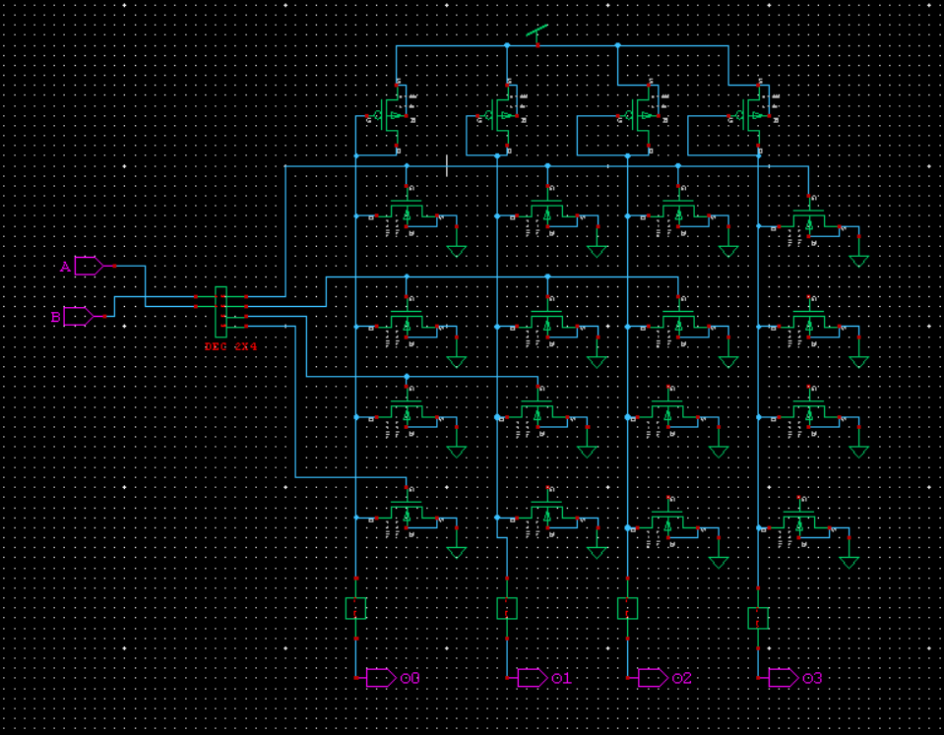

**T-SPICE**

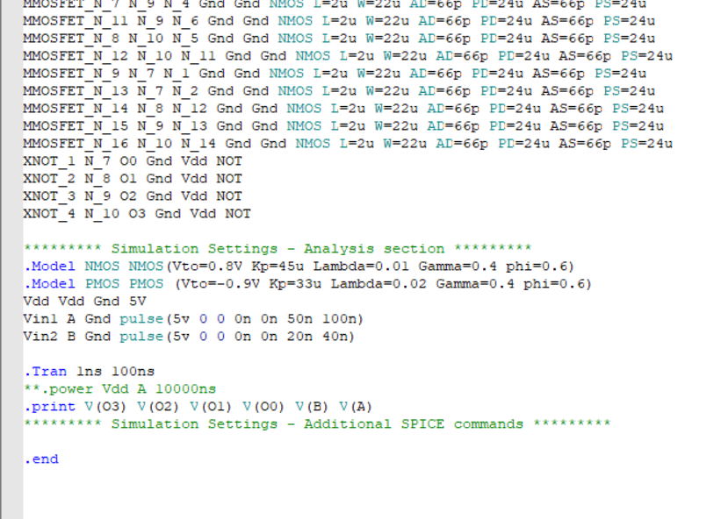

**W-EDIT WAVEFORM**

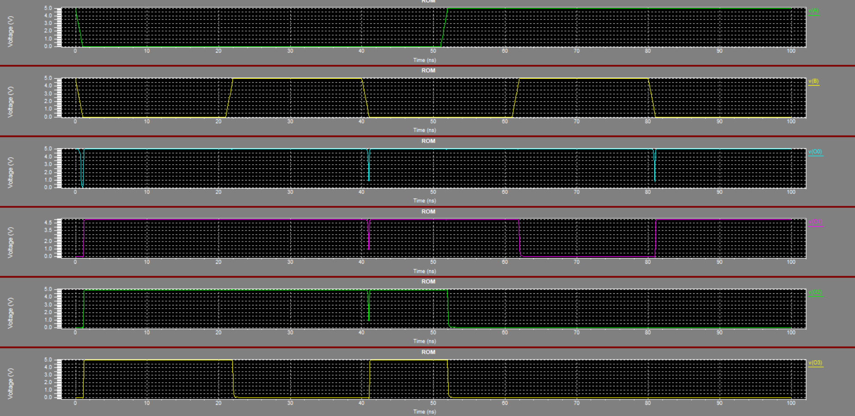

**4X1 MUX**

**S-EDIT**



**T-SPICE**

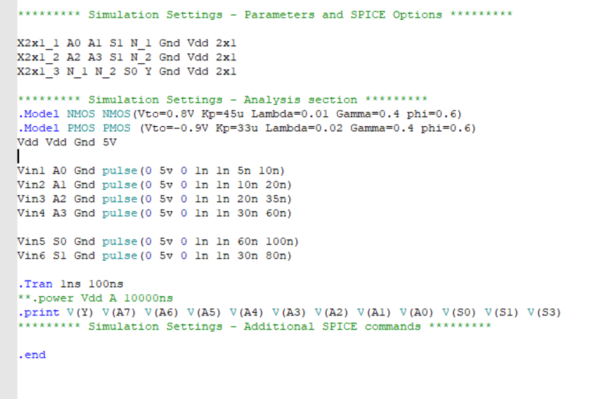

**W-EDIT WAVEFORM**

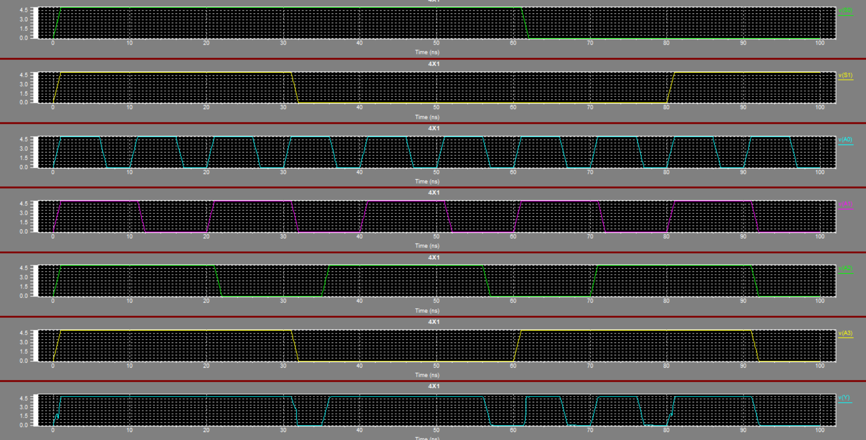

**2X1 MUX**

**S-EDIT**

**GATE MODEL**

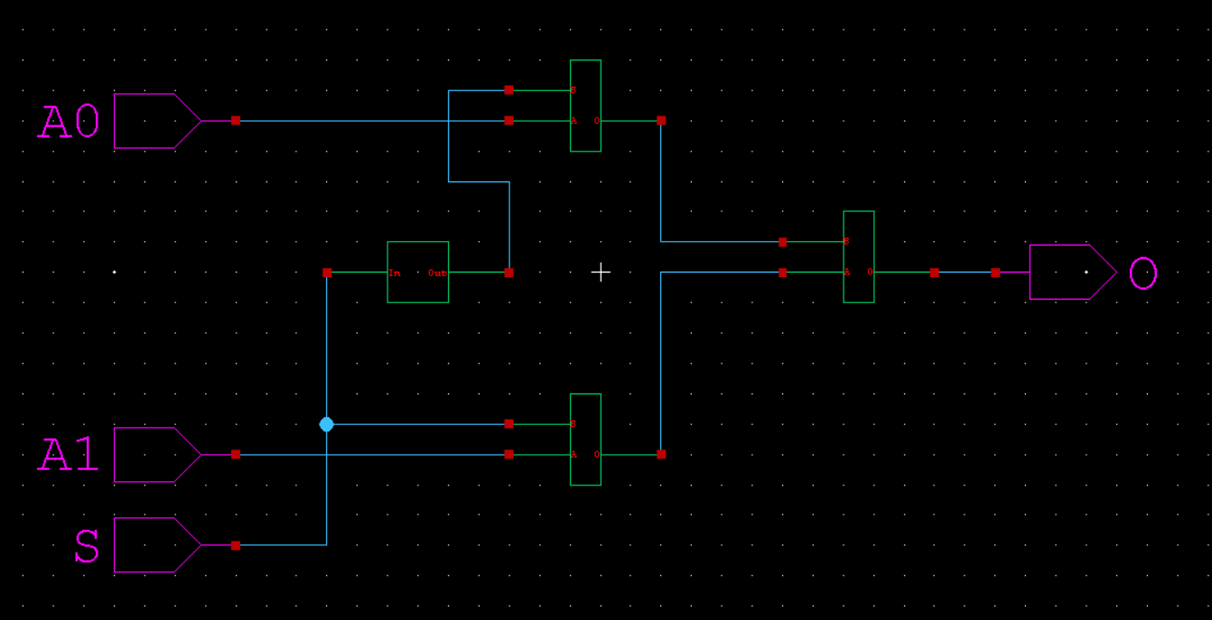

**TRANSITION MODEL**



**T-SPICE**

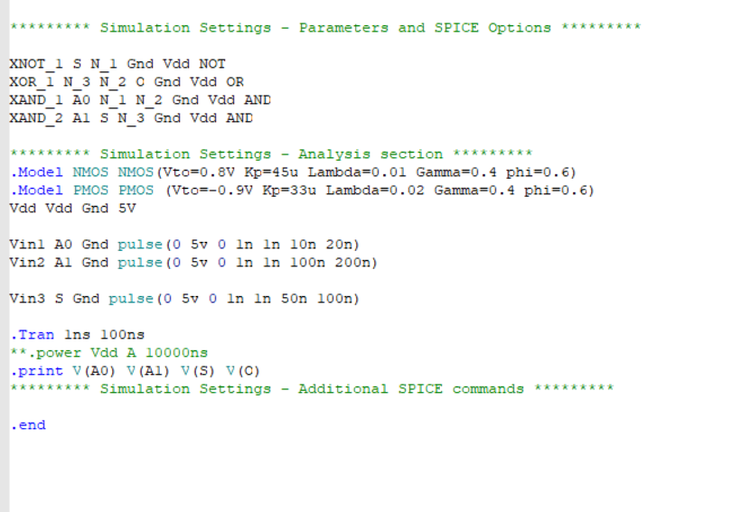

**W-EDIT WAVEFORM**

